CORPORATE SECURITY SERVICES

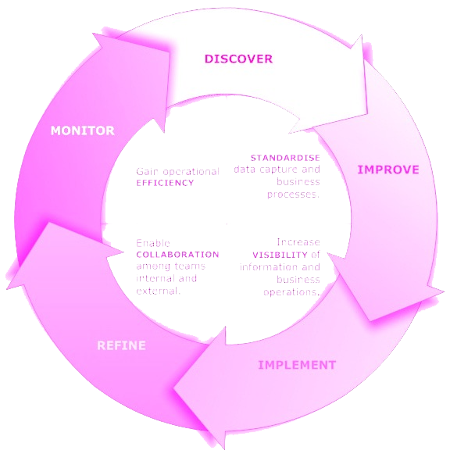

13/12/2017
Kishore [CLIENT.Company] [CLIENT ADDRESS]

Dear [MR MS] reddy,

Re: Enclosed Software Proposal

Please find enclosed our detailed software proposal for your kind consideration.
At ProDesign Technologies we are aware that creating client-oriented software takes a mixture of technical excellence and clear communication and our firm hires only the very best to ensure you receive both. We know that every client is unique and we strive to deliver an individual, innovative and affordable proposal every time and to follow it through with an outstanding delivery which is both on time and within budget.
We have over 6 years of development in this area . Please let us know if you would like to get in touch with our existing clients from whom you will receive nothing but positive endorsements. You may also wish to review our website at www.prodesigntek.com to see our portfolio of previous work and learn more about our organization.
We also pride ourselves on our after-sales client-care including our guarantees, staff- training and onsite and offsite support.Finally, we realize that you are very busy and wanted to thank you in advance for your time spent reviewing our proposal.

Yours Truly,
Kishore

- Project Overview
- Obstacles
- Industry and Market
- Budgetary Risks
- Technology Requirement Software
- Milestones and Reporting
- Deployment
- Testing
- Documentation
- Support
- Pricing
- Payment Terms
- Contact Us

Executive Summary

The following is a proposal for a Corporate Services Project consisting of the continuous aid in automation, regulation and monitoring of an organization’s operations. Our goal is to encompasses all the tasks, events, performances and outcomes of an organization. Its universal accessibility within an organization interconnects a traditional hierarchy though multi-way flow of communication. It improves the sense of responsibility and commitment in all the employees thereby ensuring quality input. Irrespective of the size of the organization, application brings everyone together to work towards the success of the organization.
Hence we believe that every action, big or small, that takes place in an organization plays an important role in building its success quotient. In order to control the end-result, the actions and events have to be controlled.

- PROJECT OVERVIEW
The Project Overview in Corporate Services Application is a detailed illustrator of all the positions and roles of each and every employee of an organization. Irrespective of the organization’s size, structure and industry, one can see an overview of the complete set of business activities and processes. It improves communication by creating an active engaging environment amongst the employee.
The Overview Dashboard also features an option for viewing the hierarchy according to the preference of the visitor. One may view the entire organization hierarchy and trace the processes or choose department-wise, project-wise, geographical operations-wise views. This not only simplifies a dense organization but also outlines everyone’s place in the organization thereby avoiding noise and inefficiency. It provides a standard platform for all the employees, tools and activities. Depending on the type of organization, the Dashboard could be customized to suit the organization’s needs.

- OBSTACLES
Here we overcome with interaction between employees and management using Live chat/video call. The Head of the organization can track the performance of each and every employee from any where and at any time. There is Communication strategy across organization.
- INDUSTRY AND MARKET RISKS
It is solution to improve the performance and progress of the Organization. where we provide interaction between the employee and management.
One of the key tenets of using CSS system within an enterprise is to externalize all business processes that are embedded deep in applications into a central location and orchestrate the flow of the process.
- BUDGETARY RISKS

- SOFTWARE
PROGRAMMING LANGUAGES : JAVA DATABASE : MYSQL
UI TECHNOLOGIES : HTML , CSS, J QUERY, BOOTSTRAP
JAVA SCRIPT OPERATING SYSTEM : LINUX
- MILESTONES AND REPORTING
- Analysis
- Development
- Testing
- Deployment
- Training
MILESTONE | TASKS | REPORTING | HOURS | DATE
1.1 | Analysis and design stage, gather data and create system mockup | None | 20 | 21/3/2017
1.2 | Architecture design | None | 5 | 23/3/2017
1.3 | Design work plan (distribution of tasks to development teams) | Team meeting to review work plan | 10 | 25/3/2017
2.1 | Create database | None | 5 | 28/3/2017
2.2 | Import existing data | None | 5 | 30/3/2017
2.3 | Clean Data | None | 3 | 31/3/2017
2.4 | Integration with outlook | None | 7 | 2/4/2017
2.5 | Integration with Smartphone Network(Mobile Responsive) | None | 10 | 5/4/2017
3.1 | Alpha Testing Desktop Application (Closed) | Email Report | 25 | 14/4/2017
3.2 | Alpha testing Smartphone Application(Closed) | None | 25 | 24/4/2017
3.3 | Finalise documentation | None | 20 | 27/4/2017
4.1 | Deployment into Server | None | 5 | 29/4/2017
4.2 | Inhouse training | Team Meeting | 10 | 1/5/2017
4.3 | Adhoc training | None | 5 | 3/5/2017

DEPLOYMENT

The software will be distributed in the following manner/s:
- Released the version of the product.
- Installation and Activation of the application and software.
- Uninstalled the application for further updates.
- Updated the application and released new version.

- TESTING
The testing process shall be as follows:
- Preparation of Test Scenario's, Test cases and Test Data
- Executing the Test cases with Data on Software.
- Converting the Test Scenarios and Cases into Test Scripts.
- Executing the Test Scripts on Software for Re and Regression Testing purpose.
- Running these scripts as Test Suite using TestNG.
- Software for Automation testing: Selenium.
- DOCUMENTATION
The document provided will be as follows:
- Gathering the requirements and prepare BRS(Business Requirement Specifications)
- Analysing the requirements and prepare SRS(Software Requirement Specifications)
- Converting the requirements into design(HLD & LLD's) using SRS.

- SUPPORT
While using our Product, if end users faces any issue we will provide support from our team. We will always be with our clients.

- PRICING
Our fee for seeing the project through from start to completion will be [FEE]. This is calculated at an hourly rate of [RATE].

- PAYMENT TERMS
We propose the following payment terms:
25% (25%) Paid on acceptance of this Proposal and signing of our software development agreement.
- 25% (50%) Paid at completion of Milestone
- 25% (75%) Paid at completion of Milestone
- 15% (90%) Paid at completion of Milestone
- 10% (100%) Paid at completion of Milestone
- CONTACT US
You can get in touch with us in any of the below ways:
By Phone : 8340906773, 040-6999 9905
By Email :info@prodesigntek.com, hr@prodesigntek.com
On our website : www.prodesigntek.com
By Post : #003, H.No:8-2-182/1,
Srinagar Colony, punjagutta,
Hyderabad- 500082.

If you would like to proceed with our proposal then you can sign the first page and return a copy to us by fax, email or post.
In any case please feel free to call us to discuss the quote, request more information or for any other reason.
We look forward to hearing from you soon!

